O1 JMC15

Transition between chaotic and self-organized patterns during femtosecond laser writing in glass: a tool for investigating glass fracture mechanics

C.-E. Athanasiou¹, M.-O. Hongler², Y. Bellouard¹

1 Galatea Lab, STI/IMT, Ecole Fédérale Polytechnique de Lausanne (EPFL), Rue de la Maladière, 71b, Neuchâtel, CH-2002, Switzerland
2 STI/IMT, Ecole Polytechnique Fédérale de Lausanne (EPFL), Lausanne, Switzerland
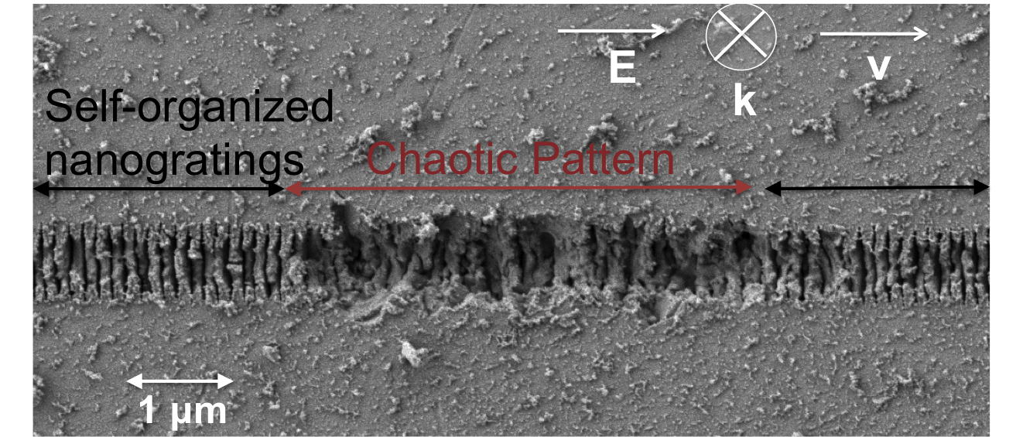
Under certain laser exposure conditions, self-organized patterns form in the bulk and on the surface of transparent ¹. These patterns (Figure 1) consists of sub-wavelength nanoplanes that self-organized, parallel one to another, and oriented perpendicular to the laser light polarization. Associated with the formation of this regular pattern is the generation of compressive stress². Recently, we reported³ that under certain exposure condition, nanogratings transition intermittently and spontaneously between disordered and self-organized . While the transitions from self-organized nanogratings to disordered patterns can be interpreted from the occurrence of catastrophic event such as crack formation that destabilizes the system, the underlying physical mechanisms allowing the material to self-heal from disordered to self-organized structures is intriguing and remains unclear.
Figure 1: Transition from an organized to a chaotic pattern and back again while writing lines with a femtosecond laser on the surface of a fused silica substrate.
Here, we discuss our investigation of the randomness and fluctuations of the process, from both macroscopic –energetic- as well as microscopic viewpoints. In particular, we will present our latest results indicating that the intermittency shares phenomenological similarities with queueing system dynamics. Furthermore, we shall discuss on how the randomness of the process may find its origin in fracture mechanics and how this can potentially be used to extract relevant statistics such as the Weibull law.

- Bonse J., Kruger J., Holm S., Rosenfeld A., Femtosecond laser-induced periodic surface structures, Journal of Laser Applications 24, 042006, 2012
- Champion A., Bellouard Y., Direct volume variation measurements in fused silica specimens exposed to femtosecond laser, Optics Materials Express 6, 165240, 2012
3. Groothoff N., Hongler M.O., Kazansky P., Bellouard Y., Transition and self-healing process between chaotic and self-organized patterns observed during femtosecond laser writing, Optics Express 23, 16993-17007, 2015

1

