O1 JMC15

Magnetic (and plasmonic) approaches to nanomedicine:
from thermal cancer therapies to tissue engineering.

C. Wilhelm¹

1 Laboratoire Matière et Systèmes Complexes, Univ Paris Diderot, CNRS UMR 7057, Paris, France.

To overcome some of the limitations of current cell therapies tools, new strategies have emerged since the advent of nanotechnology in medicine¹.
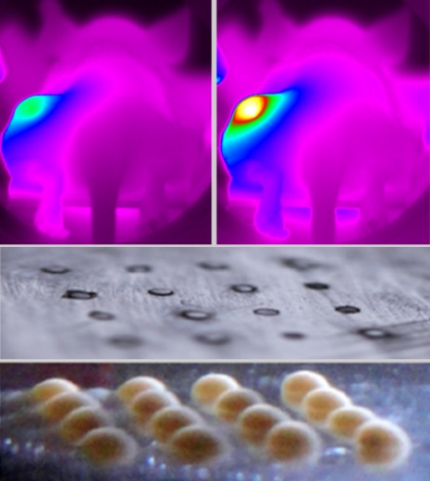
In cancer therapy, thermal treatments (magnetic hyperthermia or photothermal therapy mediated by magnetic or plasmonic nanoparticles) have provided noninvasive means of heating cells at therapeutic levels. However, while the ultimate target for nanoparticle-mediated photothermal therapy is the cancer cell, heating performance has not previously been evaluated inside the cells. In the attempt to bridge this gap, we provided the first thermal measurements mediated by magnetic or plasmonic nanoparticles inside cancer cells, in vitro or in vivo in the tumor environment. The ultimate goal of nanotherapies is anyway to improve the efficacy and combat the tumour from within. We proposed combined nanotherapeutic concepts based on magnetothermal, photothermal, and photodynamic therapies which led to complete cancer cell destruction in vitro and complete tumor ablation in vivo. While magnetic nanoparticles are increasingly used as clinical agents for imaging and therapy, their use as a tool for tissue engineering opens up challenging perspectives that have rarely been explored. Our strategy has been to take advantage of magnetic nanoparticles internalization to create thick, organized, purely cellular 3D tissue structures, which can be stimulated on demand.
Magnetic approaches in cancer therapy (top) and tissue engineering (bottom)
Finally, the use of nanoparticles for cancer cell therapies or tissue engineering raise more general issues of nanoparticles biosafety, once internalized in cells. Yet the nanoparticles long-term tissular fate is poorly documented. We have developed original magnetic and photothermal techniques to follow the fate of magnetic and plasmonic nanoparticles and their assimilation within a living tissue, and evidenced that a massive biodegradation can occur at the endosome site.

. Magnetic hyperthermia efficiency in the cellular environment for different nanoparticle designs, Biomaterials 24, 6400–6411, 2014
. Cancer cell internalisation of gold nanostars impacts their photothermal efficiency in vitro and in vivo: towards a plasmonic thermal fingerprint in tumoral environment, Advanced HealthCare Materials, 10.1002/adhm.201501035, 2016
. Combining magnetic hyperthermia and photodynamic therapy for tumor ablation with photoresponsive magnetic liposomes, ACS Nano, 9, 2904-2916, 2015; Magnetic drug carriers: Bright insights from light-responsive magnetic liposome, Nanomedicine. 10, 2797, 2015; Can magneto-plasmonic nanohybrids efficiently combine photothermia with magnetic hyperthermia? Nanoscale, 7, 18872-18877, 2015; Duality of Iron Oxide Nanoparticles in Cancer Therapy: Amplification of Heating Efficiency by Magnetic Hyperthermia and Photothermal Bimodal Treatment, ACS Nano, 10, 2436-46, 2016
. Magnetic forces promote stem cell differentiation, aggregates fusion and tissue building, Advanced Materials. 25, 2611-2616, 2013; Magnetic engineering of stable rod-shaped stem cell aggregates: circumventing the pitfall of self-bending, Integrative Biology, 7, 170-177, 2015
. Magnetic flattening of stem-cell spheroids indicates a size-dependent elastocapillary transition, Phys Rev Lett, 114, 098105, 2015

